Menstrual Hygiene Management (MHM) Waste Management Project

Milestone 3 | Local Entrepreneurship Model Concept Note

**15 December 2021**



##### 

## Background

Access to safe and dignified menstruation is a fundamental need for women and girls. A growing evidence base from low- and middle-income countries shows that many girls are not able to manage their menses and associated hygiene with ease and dignity. Although the menstrual cloth is increasingly being replaced by disposable sanitary napkins, the cloth is still the most commonly used in rural areas in low-income countries by adolescent girls and women. Over 80% of Bangladeshi women and adolescent girls in rural areas use old cloth to manage their menstruation, which is not a problem unless the cloth is unhygienic.

The initial efforts of Reemi Charitable Trust, iDE, and icddr, b. towards the research, design, and development of a practical solution to address Menstruation Hygiene Management (MHM) practices and behaviors in Bangladesh has led to the prototyping of an innovative Washer/Dryer bag solution that is in its early stages of commercialization. This combination of natural/ synthetic blend Washer and Dryer Bags are safe, discreet, and environmentally friendly for managing MHM Waste and its products can be easily done from the prototype with locally available resources and technical skills in Bangladesh, thereby making this a local product that addresses challenges around access and affordability thereby reaching women and girls in hard to reach areas providing them a means to manage their menstrual hygiene requirements with ease and dignity.

## Objective

This Concept Note’s objective is to explore a range of sales and distribution methodologies and channels with two key goals: (1) to develop an affordable and accessible delivery mechanism to reach “hard to reach” target groups; and (2) to embed such delivery mechanism within the local market ecosystem for sustainability and continuity beyond the scope of the project.

With almost 40 years of experience in working in rural and remote markets, iDE uses a unique combination of sound market and business analytics with an authentic human-centered design approach in developing interventions to context. We believe that good designs can change lives when they respond to real needs.

At iDE we operate under the ethos of actually talking to the people we work with. Only then can we work to co-design solutions that meet their particular challenges. Using an approach called human-centered design (HCD), we create products, services, and processes that fill gaps in market systems and help solve everyday problems. For example, in Bangladesh, we designed a local service provider model that powered entrepreneurial farmers to buy mechanized agriculture services (irrigation, harvesting) that allowed them to improve their productivity without investing in purchasing expensive technologies. Previously farmers were forced to either use expensive farm labor or buy the machines for their own use, locking them into a major capital investment. But by using an iDE-trained service provider to rent machines, farmers can now get the same quality of services without a major investment.

## Framing the solution the right way

We understand that selling mechanized services is different from selling a MHM solution and that the needs of a wheat farmer in Bangladesh are different from a young girl looking for a dignified and safe solution to her menstrual health needs. As such, we have utilized and relied on proven social marketing methodologies to frame the design of the solution. Of most interest to this specific solution and its marketing approach has been the review and application of PSI’s Behavior Change Framework and its use of proven marketing strategies that is succinctly framed around their social marketing interventions in the Product, Price, Place, and Promotion domains, also called the 4 Ps in marketing (Chapman, 2004).[1]

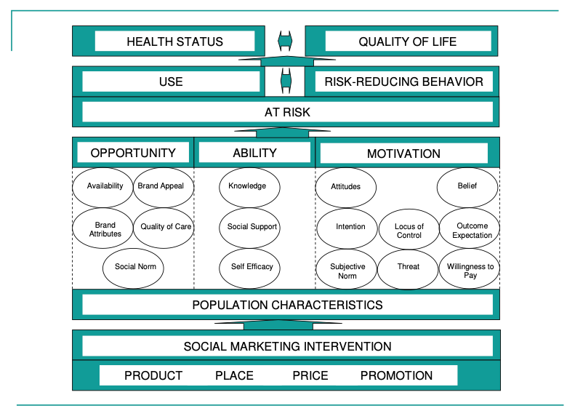

**Table 1:***PSI Behavior Change Framework for Social Marketing*

The strength of this framework is that it seeks to track and monitor the behavior change of targeted groups (for the intended behavior change), across three key behavioral determinants - Opportunity, Ability, and Motivation and its interventions on the 4 Ps domains are aligned with the behavioral determinants. For example, the framework posits that knowledge about a particular behavior or solution that affects the behavior forms the ability of the target group to use the promoted solution appropriately and that knowledge can be improved through a combination of 4Ps interventions - whether these attributes are included in the product, i.e brochure and information; or through placement/distribution - i.e. the service provider giving information; or promotion - i.e. a marketing campaign.

Although there are many other frameworks and approaches on social marketing, the core area of focus for social marketing efforts have been defined by Kotler and Lee as a marketing approach: (1) focusing on understanding the perspectives of the full range of target audiences necessary to bring about change; (2) developing a research-based program, relying on formative research to develop and test concepts with members of the target audience; and (3) recognizing the need to include all elements of the marketing mix (i.e., product, price, place, promotion) to bring about behavior change[2].

What that in mind, this concept note seeks to frame the social marketing strategies for the proposed products around 4 broad components or marketing mix - ***Product (the actual technology and its attributes); Placement - its distribution channels; Pricing - the cost of behavior change and adoption of technology by the users; and Promotion - a combination of marketing and communication initiatives that seek to increase awareness, knowledge, and use of the product***.

Further, this concept note is centered around phase 1 commercialization of the product meaning that it is pre-scaling and therefore, requires a more focused approach with the goals of reaching the target groups as efficiently as possible. Further research and market insights during phase 1 will help inform Reemi Charitable Trust, iDE, and icddr, b. in fully developing the strategies for its scale-up phase.

1. **Product and its features**

The product in this case is a combination of two items: (a) a washer bag that is made of natural/synthetic components; and (b) a dryer bag that is also made of natural/synthetic components. More details of this product can be found in the product description included in Annex A of this document. Based on the initial review of the prototypes (multiple resolutions), three core recommendations are provided:

**Recommendation # 1, naming the product:** An essential part of improving product acceptance, knowledge and awareness is to find a common and easily used nomenclature for a technology/solution. E.g. the modern version of the mobile phone which includes many features is called a “smartphone” and similarly, a disposable menstrual hygiene pad is simply called a “pad”. As such, the naming of this solution needs to take into account acceptability by the target audience, being aware of and the risk of stigmatizing the product/ solution and its practical definition is commercial activities, such as ordering of the product or asking for the product in a retail environment.

**Recommendation # 2, uncoupling the combination:** Whilst the product designers have intended the target group to purchase and use the solution in combination with each other - washer and dryer bags, it is also important to note that there may be situations where: (1) the users may only have use of one type (either a washer or dryer bag), (2) the users may have lost or worn out one type and may need to replace only one; and (3) the initial costs of the combination may prevent some users from adoption. As such, the product could have a “basic” model - just one of the technology; and a “starter kit” with both, thereby opening the market wider for adoption and decreasing the initial costs.

**Recommendation # 3, packaging:** During the initial phase of launching a new product, it is important to provide instructions on its appropriate use. As the proposed product specifications have a separate “brochure” type instruction manual, which could be misplaced or lost, it is recommended that the instructions be printed into the washer/dryer bags itself. Furthermore, an external packaging or “shell” might be needed for the product to ensure that it can be discreetly handled during transport and retail interactions.

1. **Pricing Strategy**

The market size of sanitary napkins in Bangladesh is growing rapidly. The current market size is estimated to be at $50 million sharply rising from $2.1 million in 2008, still with less than 20% of the potential users actually purchasing sanitary pads. The most popular and widely available sanitary pad is the “Senora” brand which uses a similar product and packaging design as imported (and more expensive ones) with over 60% of the market share. Broadly, the current market prices for sanitary pads are as follows:

|  |  |  |
| --- | --- | --- |
| **Brand** | **Key Attributes** | **Prices** |
| Senora | Considered to be a “foreign” brand and has aspirational marketing. Widely available and cheapest in the market. | Most commonly sold in a pack of 15 pads for Taka 130/ pack.  Taka 9 per unit/ $0.10 per unit |
| Joya | Also marketed as “foreign” but includes additional features such as “wings” and is considered a premium local brand. | Most commonly sold in a pack of 8 pads for Taka 100/pack.  Taka 12 per unit/ $ 0.14 per unit |
| Whisper | Imported (from India), considered to be expensive and of high quality. | Most commonly sold in a pack of 15 pads for Taka 360/ pack.  Taka 24 per unit/ $0.28 per unit |

**Table 2:***Price of various Disposable Sanitary Pads in Bangladesh Market*

Frequency of sanitary pad use per day per household during menstruation

|  |  |  |  |  |
| --- | --- | --- | --- | --- |
| **Flow Type** | **Number of sanitary pads per day** | **Total pads per household per month**  **(2 women per HH)** | **Cost of sanitary pads**  **per month per household** | **Key Assumptions** |
| Light Flow | 3-4 pads | 28 pads | Taka 252 | * This is based on one sanitary pad used during the night time and calculated based on 4 days of menstruation per cycle for 2 women in the household * The price used here is based on Senora Taka 9 per sanitary pad. |
| Regular | 5-6 pads | 44 pads | Taka 396 |
| Heavy | 7-8 pads | 60 pads | Taka 540 |
| Super Heavy | More than 8 pcs | 72 pads | Taka 648 |

**Table 3:** *Monthly cost of Sanitary Pads per households*

The pricing strategy of this solution needs to take various factors into consideration: (1) that there are no other solutions like these currently available in the market, therefore it is hard to benchmark the price; (2) that the solution is primarily focused on a lower income strata who is price sensitive; (3) there is an adoption cost of the proposed solution beyond the price of the product itself, i.e. cost of labor and time to wash and dry vs using and disposing of pads; (4) the solution and the market ecosystem around it needs to be sustainable beyond the project’s intervention for continuity and scale-up.

The matrix below plots seven broad categories of pricing strategies in relation to two broad business objectives or axes - cost recovery and profitability.

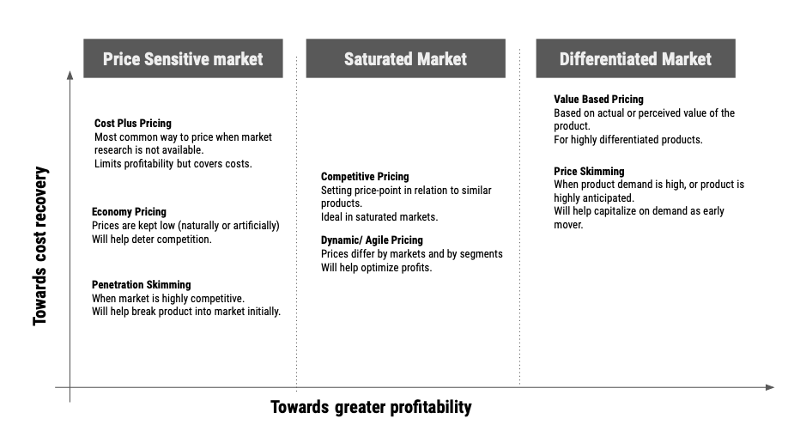

**Table 4:** *Pricing strategy and business objectives for cost recovery vs profitability*

Recommendation # 1, cost-plus pricing strategy: as the objective of this concept is to ensure higher utilization of the solution by lower-income target groups, whilst ensuring a sustainable business model - the recommended pricing strategy for phase 1 of the commercialization process would be to seek a cost-plus pricing strategy. This will need to incorporate the costs of distribution (discussed in the next section) and be further validated through a more detailed willingness to pay survey during the implementation phase. A simple recommended formula is as such:

Floor price (minimum price) = cost of goods + cost of business (overheads + marketing costs + channel costs)

**Ceiling price (maximum price)** < the current competitive product (none) or substitute product (pads)

Recommendation # 2, explore dynamic pricing strategy in the long term: for a certain target group, such as working women (e.g. RMG sector) a significant cost to adopting this solution will be switching from a ‘use and dispose’ option to this. As such, it is recommended that in the later stages of the commercialization, the product should have a dynamic pricing option where the cost price is significantly lowered to decrease the hurdle for adoption.

1. Placement/ Distribution Strategy

A large number of fast-moving consumer goods (FMCGs) in Bangladesh are channeled through an extensive producer-distributor - wholesaler - retailer network across the country that includes over 100,000 retail outlets (specialty stores e.g. medical outlets, commodity retailers e.g. food retailers, general stores e.g. local corner/ grocery stores). Most often these are a highly integrated network of buying, transporting, and logistics/ inventory management or warehousing functions that work cohesively together with producers/ manufacturers.

However, given that the production volume of our product/ solution is likely to be small in the early phases and that these are very innovative and unique products, it important to use a direct to customer channel, which may be more cumbersome and complicated to manage in the beginning than to create strategies for piggy-backing on the existing network. Based on our experience of commercializing new and innovative solutions to the rural market, iDE recommends using its proven women sales agent model for the first phase.

The Sales Agent model

In most rural markets, due to geographic limitations, cultural practices, and transaction costs - it is not always easy for consumers to get to the retail point next to them, and when they do get to the market they often face challenges related to product availability, affordability, and trustworthiness of the retailers selling the products. The sales agent model is designed to bridge the last mile between retailers and consumers, where the market is brought to the door-steps of the consumer in an affordable and accessible manner.

Within our ongoing program, iDE has used this model extensively to promote a range of products and services from appropriately packaged seed for farmers to nutrition and WASH products for lactating mothers. Furthermore, sales model approaches are used extensively in Bangladesh, initially popularized by [Bata and Care through the *Aparajita* entrepreneur methodology](https://www.theguardian.com/sustainable-business/2014/oct/20/partnerships-business-rural-workers) to develop the entrepreneurial capacity of local women and help them create rewarding livelihoods serving their communities.

The sales model approach begins with the selection of sales agents from the community. As pools of **Sales Agents** from various development projects are already deployed in the rural areas in Bangladesh, identifying and selecting these agents should not be very challenging. These sales agents are then provided with product orientation, which includes building their capacity on “pitching” the product and talking about the features and benefits of the product. To augment their abilities, most often sales agents are provided with brochures, handouts, and marketing materials. In some instances where product use requires additional knowledge from the users, sales agents are also used as the last mile outreach workers to disseminate this information.

On the business side, these sales agents are linked with local retail/ wholesale points through which they can access their inventory. Depending upon the situation, but more often than not, sales agents are given inventory credit for a short period of time (2 weeks to a month). This helps address the immediate cash flow issues for sales agents and also provides sales agents the ability to sell in credit to their customers (at their own discretion) when they want to.

Once transactions are completed, sales agents often return back to the retail/ wholesale points to pay their dues (sales price minus their commission) and record the sales. In some cases, retailers/ wholesalers offer additional incentives for sales agents if they meet and exceed their sales quotas or pay on time. Again, these distribution channel incentives are often left to the discretion of the retailer/wholesaler and sales agents to negotiate between and amongst themselves whilst we encourage competitive practices. 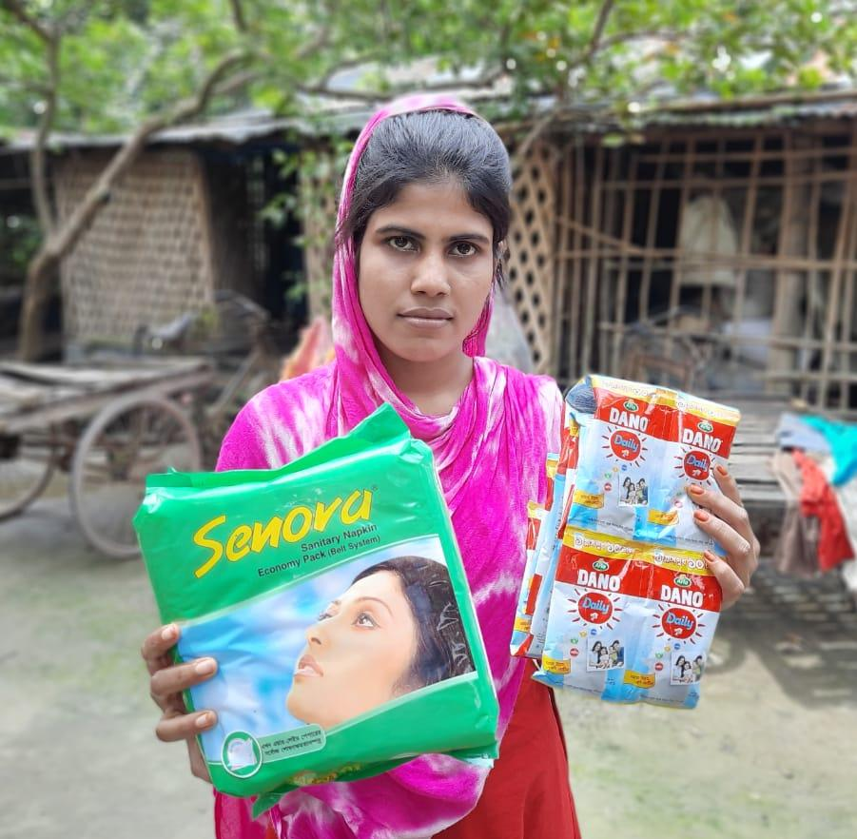

**Photo 1:** *Women Sales Agent in our WEESMS program selling Senora Pads.*

Recommendation # 1, strategic selection of sales agent cohorts: given that the initial phase of the project is likely to use a direct-to-consumer approach through the sales agent, the success of the model depends upon the sales agents themselves. As such, the selection of these sales agents and their placements (which areas they cover) is vital for the initiative. As explained earlier, a large number of development programs and commercial firms are using sales agents in Bangladesh, and therefore it is recommended that the selection should consider: (1) geographical location - where we want to first start this initiative from; (2) clusters of target groups, e.g. schools/ colleges, RMG factories; and (3) potential partnership with development programs that are already doing this, e.g. iDE is working in Cox’s Bazaar promoting MHM products within schools under their PSM project.

Recommendation # 2, partnership with intermediary retailer/ wholesaler: the hub-spoke model of the sales agent hinges around a local retailer/wholesaler and therefore partnership with the most appropriate one is highly recommended. This partner will be pivotal in ensuring a consistent and smooth supply of products, providing inventory credit to the sales agent, engaging in transactions on behalf of the producer, and keeping an overall “eye” on the market, i.e. as a market intelligence partner. Some selection criteria could include - overall experience in managing a sales agent approach, business acumen and credibility, interest in this product, and transparency in doing business.

Recommendation # 3, training and marketing support for sales agents: in most cases, sales agents carry a “basket” of goods and have been trained on selling these items to their consumers. As such, adding on a new product will require additional training and orientation on the product as well as marketing support in the form of flyers/ brochures which is discussed more in the next section.

Recommendation # 4, incentivizing the sales agent: as discussed earlier, the “basket” of goods that the sales agents carry may or may not include substitute products. In such cases, it is important to ensure that the pricing strategy of the product adequately incorporates a meaningful incentive as their commission and it is worth their while to transport and sell these products. Furthermore, if sales agents sell the product on credit, the incentive needs to reflect the cost of risk that they are willing to take in offering credit to their consumers.

1. Promotion/ Marketing Strategies

At the outset of this section, it should be noted that iDE does not recommend a large-scale above the line promotional/ marketing campaign at this stage. The reasons for this are multiple: (1) that any increase in the “cost of doing business”, including investment in media for this product will increase its price to the consumer as its pricing is likely to be based on a cost-plus pricing strategy, and our objective is to keep this product as affordable as possible; (2) investment for large scale behavioral change campaigns are likely not the best use of our resources and there are other agencies that are best fit for this job; (3) that large scale investment in media campaigns need to be based on keen behavioral insights of the target audience, and we don’t yet have all the information which is likely to result in low return on investment; and (4) during the initial phase, production volumes will be relatively low thus not requiring a mass media campaign.

With those assumptions, iDE recommends the following key activities centered around more cost-effective use of below-the-line activities[3].

Recommendation # 1, invest in sales agent training: linked to recommendation # 3 under the placement strategy, the most effective use of resources would be to provide ample training and orientation to the sales agent in the effective sales and marketing of the product. Often referred to as Interpersonal communication (IPC) activities, these are the hallmark of good behavior change communication practices. Our strategy should change when we increase the scale of production and sales in the subsequent phases as IPC activities are often not very cost-effective on a larger scale, but for the initial phase, this should be the prioritized area of investment.

Recommendation # 2, partner with technical agencies for support: organizations like WASH United provide free or low-cost training and media packages focused on increasing MHM awareness, training, and technical support. Partnerships like these will provide a quick boost to the Reemi Charitable Trust, iDE, and icddr, b consortia to use existing contents and contextualize it for our own use during the sales and promotion of the product.

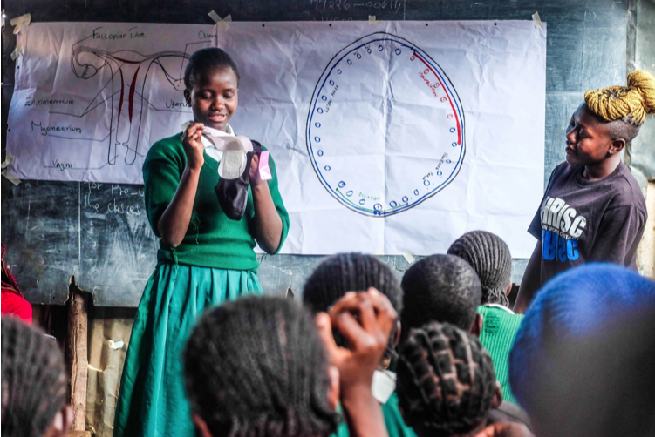

**Photo 2:** *WASH United School training in Kenya.*

Recommendation # 3, use commercial marketing strategies for product promotion: commercial firms use a range of promotional items and giveaways to promote their products. These low cost items are often an ancillary product to the main one, e.g. a free mug when you buy a packet of coffee, or a low-cost toothbrush when you buy a toothpaste. Similar ideas can be utilized to bundle this product, e.g. with existing reusable pads, use ancillary promotional items such as liquid soap sachets to increase its attractiveness.

Annex A | Product Sheet for Natural/ Synthetic Blend Washer and Dryer Bags

Product Sheet for Natural/Synthetic Blend Washer Bag

**Key Features:**

* Easy cleaning of reusable menstrual cloth
* Allows privacy while use and maintenance of reusable menstrual cloth
* Disposal of dirty water and washing menstrual cloths without touching by hand
* Convenient to manufacture locally
* Made using natural/ synthetic blend fabric

**Specifications of Water Resistant Fabric:** **Specifications of the Washer Bag:**

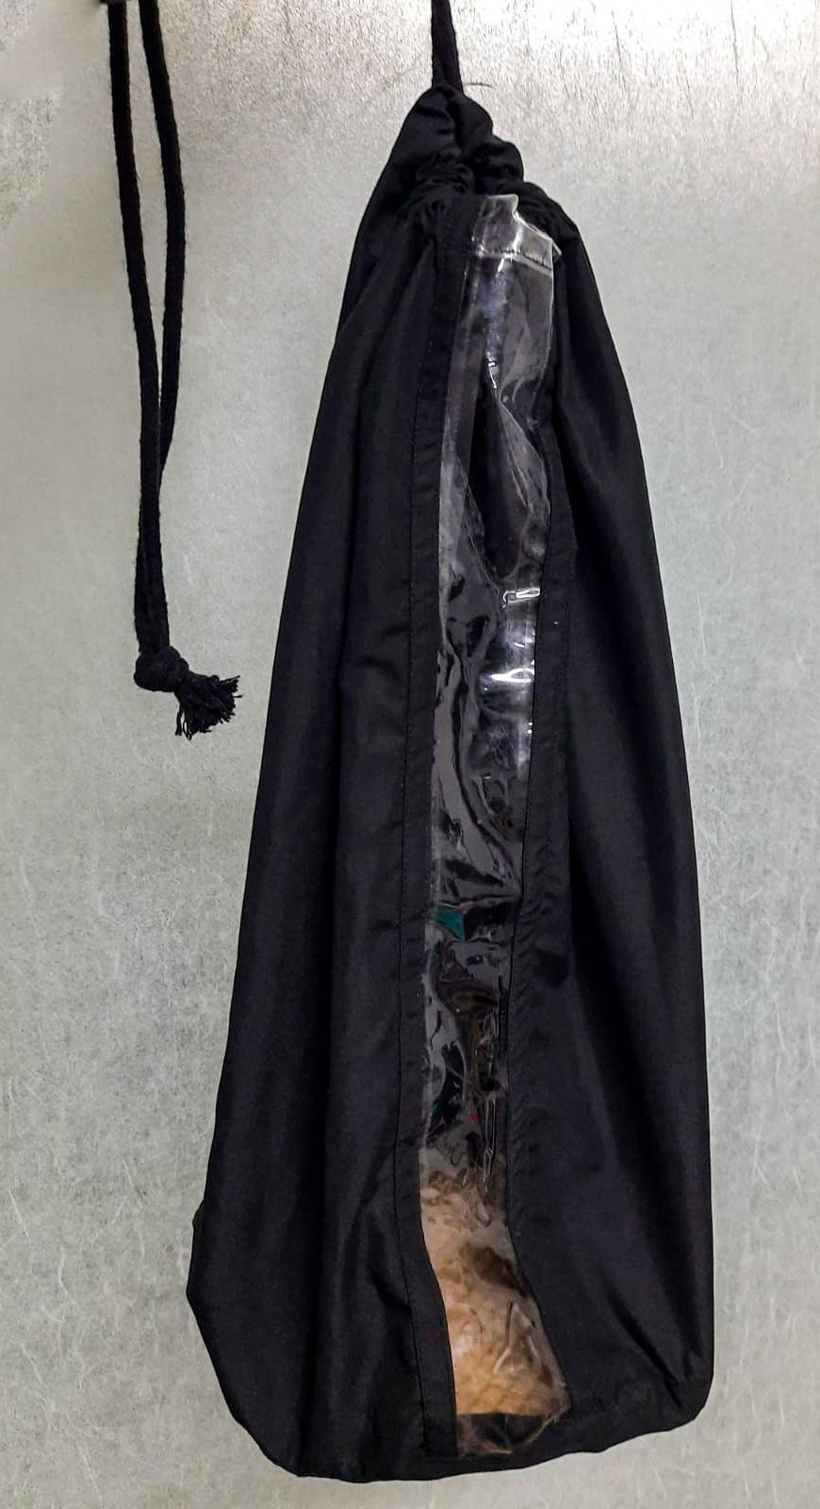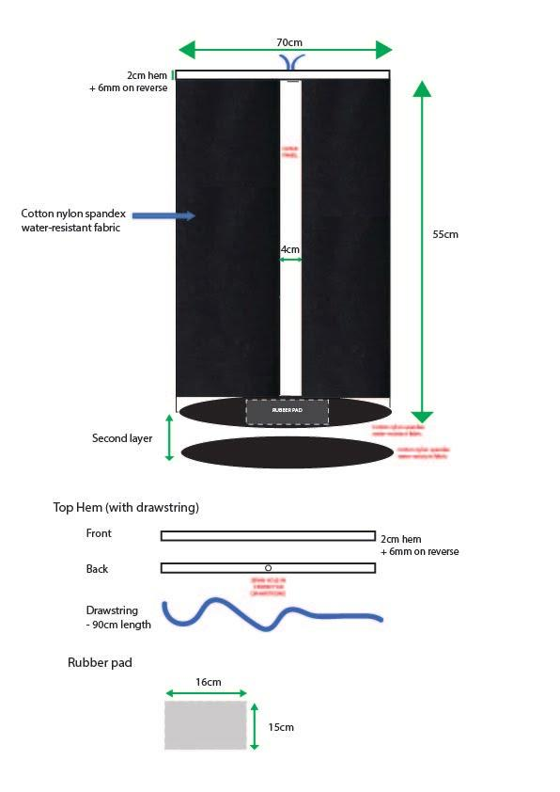

|  |  |
| --- | --- |
| * **Fabric :** Cotton Nylon Spandex, Water-Resistant Fabric * **Materials Composition:**   + Cotton: 71%   + Nylon: 26% and   + Spandex: 3% | * Cylinder shaped bag * 55 cm in Height * Perimeter of the cylinder bag - 70 cm * Clear Layer for visibility of 4cm * Rubber Pad inside - 16X15 Cm |

INSTRUCTIONS FOR THE WASHER BAG

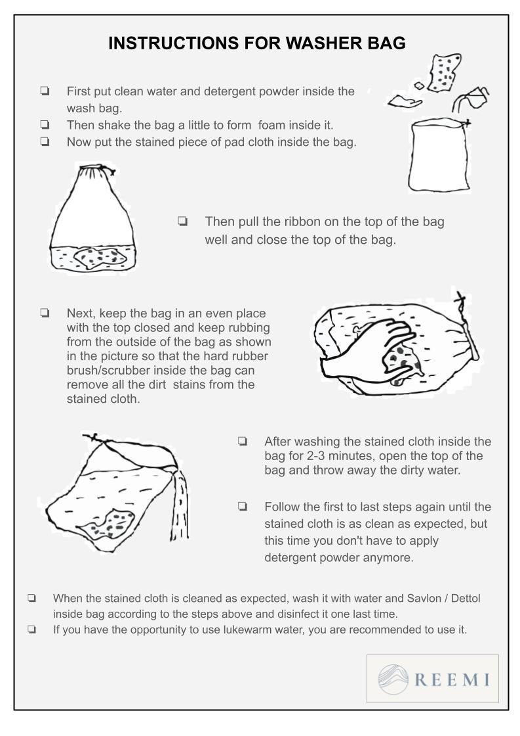

Product Sheet for Natural/Synthetic Blend Dryer Bag

**Key Features:**

* Dryer bags easy to hide the menstrual used cloth
* Can dry outside under direct sunlight as the sanitary napkin is not visible
* Long-lasting, therefore cheaper to use.
* The darker fabric helps to dry fast.

**Specifications of Dryer Fabric Specifications of the Dryer Bag**

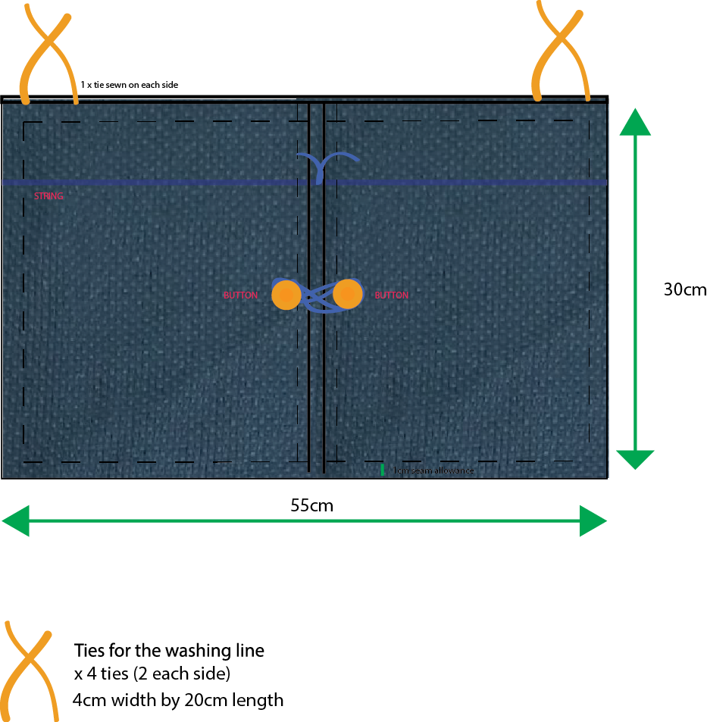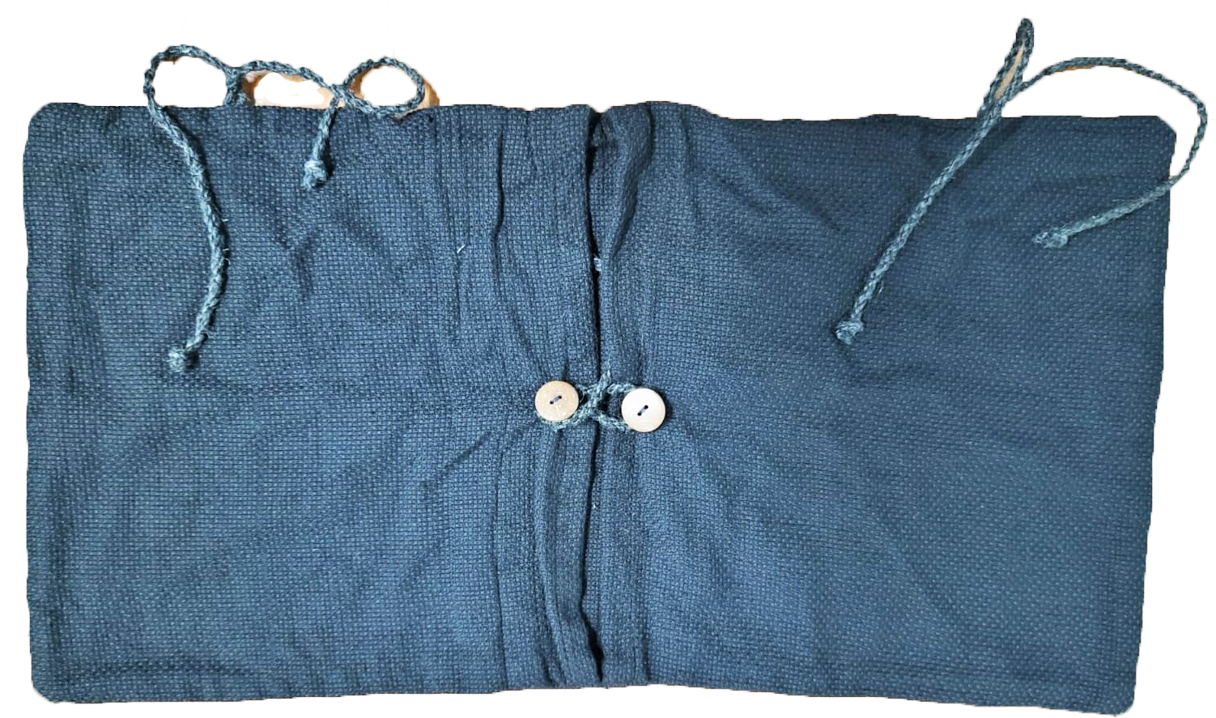

|  |  |
| --- | --- |
| * **Fabric:** Cotton Breathing Fabric * **Materials Composition:**   + Cotton: 100% | * Rectangular shaped bag * 30 cm in height * 55 cm length * Wires wires to tie it for drying * Locking system with wire and button. |

INSTRUCTIONS FOR THE DRYER BAG

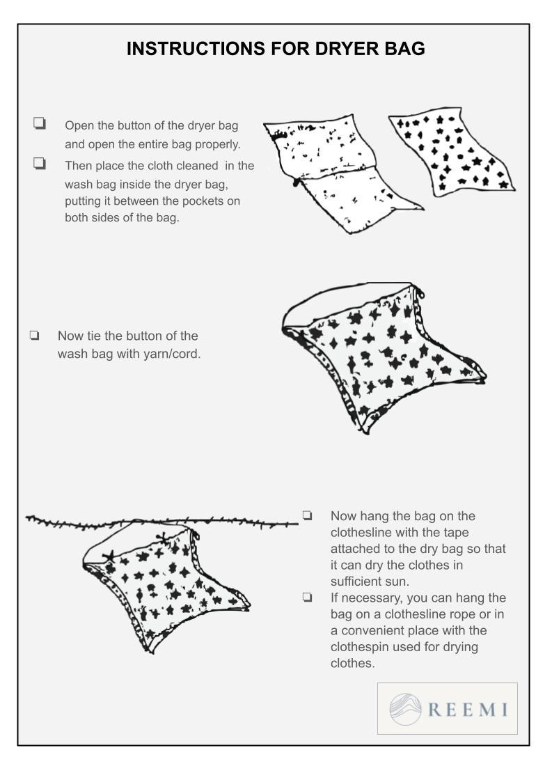

Annex B | Product Pricing

**Pricing Details of the Products**

|  |  |  |  |
| --- | --- | --- | --- |
| **Price Comparison** | | | |
| **Prototype A | Version 1 Washer Bag using Laminated Jute & Rubber Scrubber** | | | |
| S.N. | Items | Amount in Taka | Amount in USD |
| 1 | Jute Laminated Fabric | 22 | 0.25 |
| 2 | Rubber shoe sole scrubber | 54 | 0.63 |
| 3 | Regular clear PVC | 13.33 | 0.15 |
| 4 | Fiber Rope (Jute) | 1.05 | 0.01 |
| 5 | Adhesive Glue | 13 | 0.14 |
| 6 | Sewing Thread | 3 | 0.03 |
| 7 | Labor cost | 48 | 0.56 |
|  | **Total** | 153.88 | 1.80 |
|  | Overhead Cost (58.93%) | 90.68 | 1.06 |
|  | **Subtotal** | **244.56** | **2.87** |

|  |  |  |  |
| --- | --- | --- | --- |
| **Price Comparison** | | | |
| **Prototype A | Version 2 Wash Bag using Beeswax-coated Cotton & Coconut Shell Scrubber** | | | |
| S.N. | Items | Amount in Taka | Amount in USD |
| 1 | Bee Waxed laminated cotton fabric | 337 | 3.95 |
| 2 | Coconut shell scrubber | 1,000 | 11.74 |
| 3 | Sonali Bag | 2 | 0.02 |
| 4 | Fiber Rope (Hemp) | 5.06 | 0.05 |
| 5 | Adhesive Glue | 13 | 0.14 |
| 6 | Sewing Thread | 3 | 0.03 |
| 7 | Labor cost | 48 | 0.56 |
|  | **Total** | 1,407.56 | 16.53 |
|  | Overhead Cost (58.93%) | 829.47 | 9.74 |
|  | **Subtotal** | **2,237.04** | **26.27** |

|  |  |  |  |
| --- | --- | --- | --- |
| **Price Comparison** | | | |
| **Prototype B | Version 1 Dryer Bag using Jute Cotton Fabric** | | | |
| S.N. | Items | Amount in Taka | Amount in USD |
| 1 | Jute cotton fabric | 31.66 | 0.37 |
| 2 | Wooden Button | 6 | 0.07 |
| 3 | Fiber Rope (Jute) | 2.8 | 0.03 |
| 4 | Sewing Thread | 3 | 0.03 |
| 5 | Labor cost | 48 | 0.56 |
|  | Total | 91.46 | 1.07 |
|  | Overhead cost (58.93%) | 53.90 | 0.63 |
|  | **Subtotal** | **145.36** | **1.70** |

|  |  |  |  |
| --- | --- | --- | --- |
| **Price Comparison** | | | |
| **Prototype B | Version 2 Dryer Bag using Cotton Fabric** | | | |
| **S.N.** | **Items** | **Amount in Taka** | **Amount in USD** |
| 1 | Cotton fabric | 26.66 | 0.31 |
| 2 | Coconut Shell Button | 4 | 0.04 |
| 3 | Fiber Rope (Hemp) | 17.14 | 0.20 |
| 4 | Sewing Thread | 3 | 0.03 |
| 5 | Labor cost | 48 | 0.56 |
|  | Total | 98.80 | 1.16 |
|  | Overhead cost (58.93%) | 58.22 | 0.68 |
|  | **Subtotal** | **157.03** | **1.84** |

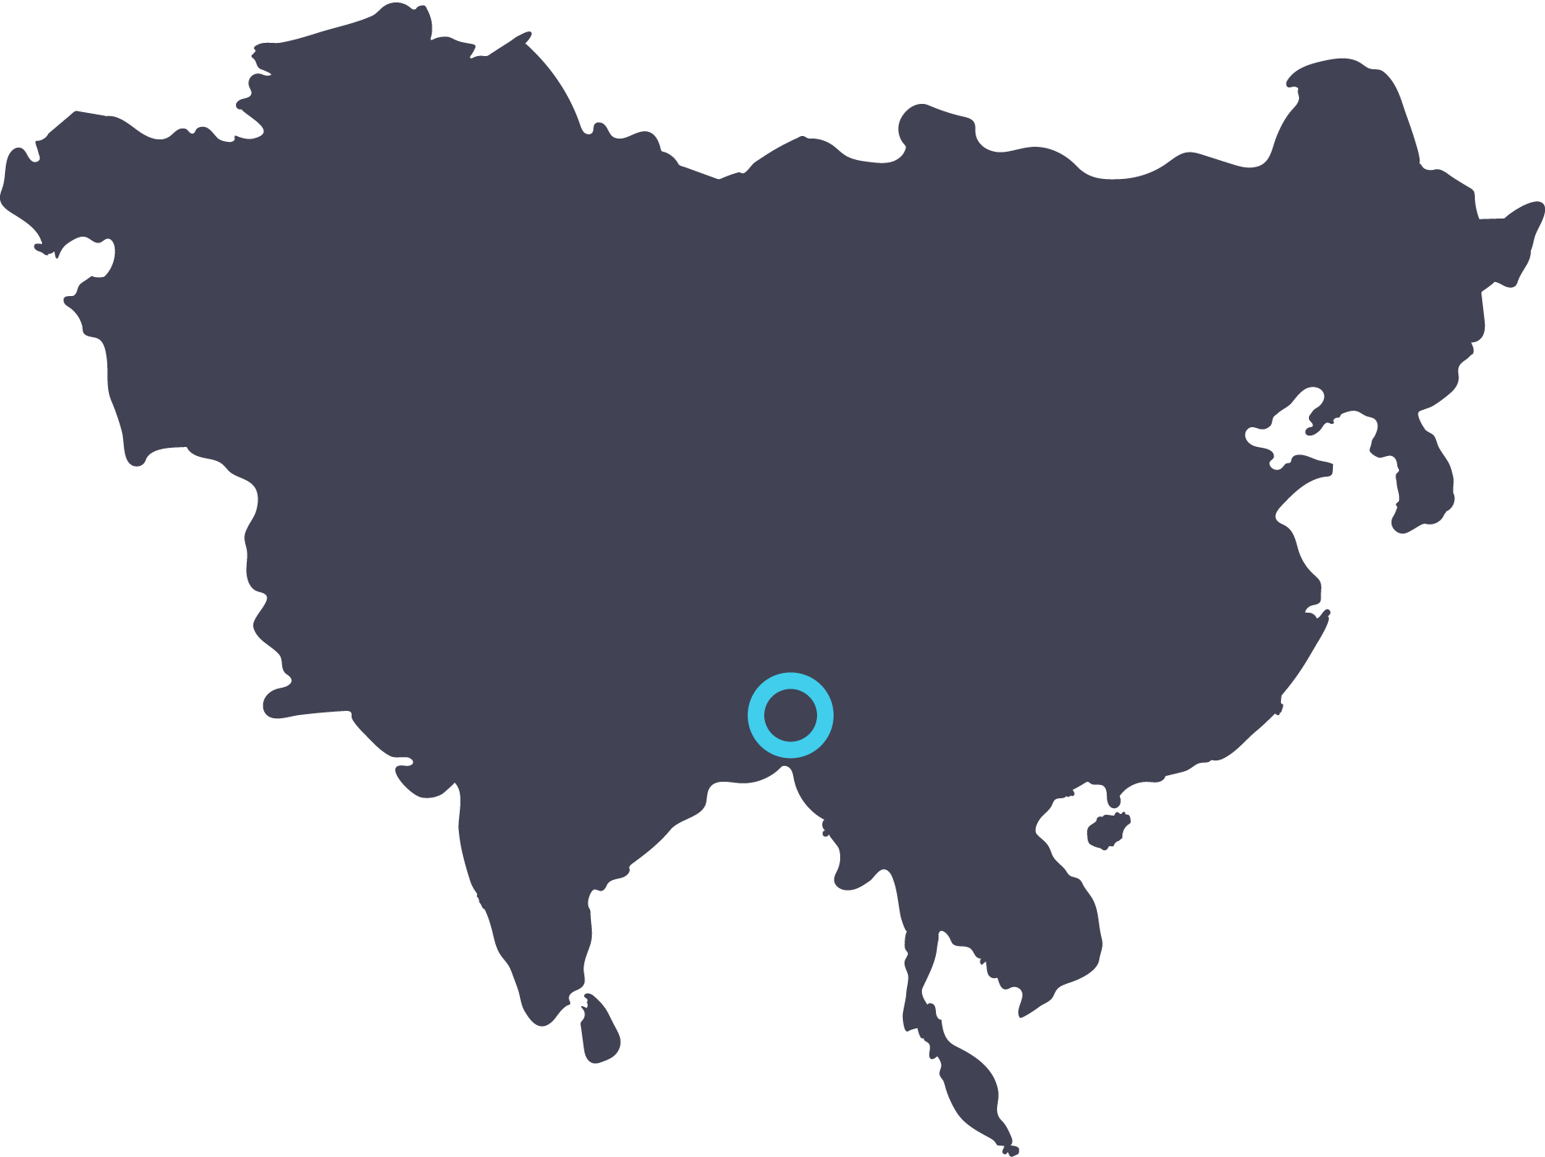

**iDE in Bangladesh**

Saroja Thapa

Associate Program Director

[sthapa@ideglobal.org](mailto:sthapa@ideglobal.org)

1. Chapman, Patel. Concept Paper on PSI Behavior Change Framework “bubbles”: proposed revision, 2004.
2. Lee N, Kotler P. Social Marketing: Changing Behaviors for Good. Sage Publications; 2015
3. Below-the-line advertising is an advertising strategy where products are promoted in media other than mainstream radio or television. Below-the-line advertising campaigns include brochures, flyers, message boards and interpersonal communications (IPCs).